

Databases for Business Analytics – BANL 6430

Online Analytical Processing Homework

1. Create a new OLAP cube to help the Finance department of the company with its analytics needs.
Create a new cube, a new data connection and a new data source view. The measures of the cube will come from the table FactFinancetable in the database AdventureWorksDW.

Name the cube, data connection and data source view with the object name, your name, and "_Finance extension".

For example, for the cube: Cube_SmithJohn_Finance.
For the data connection: Connection_SmithJohn_Finance
For the data source view: DataSourceView_ SmithJohn_Finance

2. Measures for the Fact table.
All the measures in the FactFinance table should be included in the cube.

3. Create a date dimension for the cube.
The date dimension for the cube should contain the following attributes from the DimDate table:

- EnglishDayNameofWeek
- WeekNumberOfYear
- EnglishMonthName
- CalendarQuarter
- CalendarYear

4. Create an Account dimension for the cube.
The Account dimension for the cube should contain the following attributes from the DimAccount table:

- AccountType
- AccountDescription
- AccountCodeAlternateKey

5. Create an Organization dimension for the cube.
The Organization dimension for the cube will contain only the following attribute from the DimOrganization table:

- OrganizationName

6. Publish your cube to your local Analysis server.
Make sure to use the correct name for your local analysis server in the "deployment properties" of your "OLAP_HW" cube exactly the way we have done it in the lab.
Also, make sure that for the OLAP homework cube deployment you use the "sa" account and not the win/authorization account. Save your password as well like in the image below.
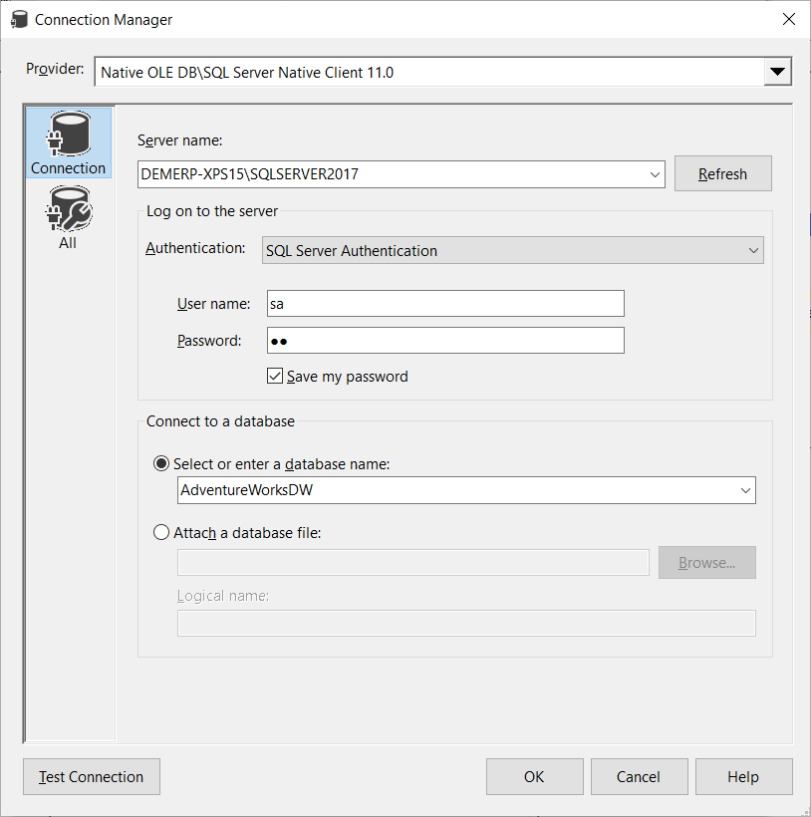

7. Use Excel to connect to the OLAP cube you have just created and obtain the following pivot table reports:
Create all three reports in the same workbook in different worksheets.

a. Calculate the sum of Amount by CalendarYear and Organization.

b. Calculate the sum of Amount by AccountDescription and CalendarQuarter

c. Calculate the sum of Amount by AccountCodeAlternateKey and EnglishMonthName.

Upload your OLAP homework project files as well as the Excel workbook to your OLAP assignment on the class web site.

